CSYE 7280 User Experience Design and Testing

**Low Fidelity Prototype**

**Team Name: CareConnect**

| **NU ID** | **Team Member Name** | **Contribution** |
| --- | --- | --- |
| 002713929 | Habeebuddin Mir | Prototype I |
| 002778147 | Maseerah Khatoon | Prototype II |
| 002796856 | Shaiz Akhtar | Prototype III |

**Supervisor – Prof. Svetlena Taneva Metzger, PhD**

Master of Science in Information Systems

College of Engineering

Northeastern University, Toronto

**Prototype I**

Habeebuddin Mir - 002713929

Description: This low fidelity prototype is made based on extensive evaluation

on the feedback received during the user needs and assessment sessions.

It accomplishes critical tasks required to search for doctors and book an appointment.

Tasks:

1. Build a Profile

a. Enter Basic Data

b. Fill out Medical History

c. Fill out Lifestyle factors

d. Hit Save button

1. Search Doctors

a. Enter search query

b. Set filters

c. Access list of doctors

d. View doctor’s profiles

1. Book appointment

a. Select date

b. Select time slot

c. Choose appointment mode

d. Review pre-appointment checklist

Link to Prototype:

<https://www.figma.com/file/FeIStZf5HmBtOgePAmvJJ2/LFP?type=design&node-id=0%3A1&mode=design&t=LM0v2JSqlXz9g21F-1>

1. **Build Your Profile**

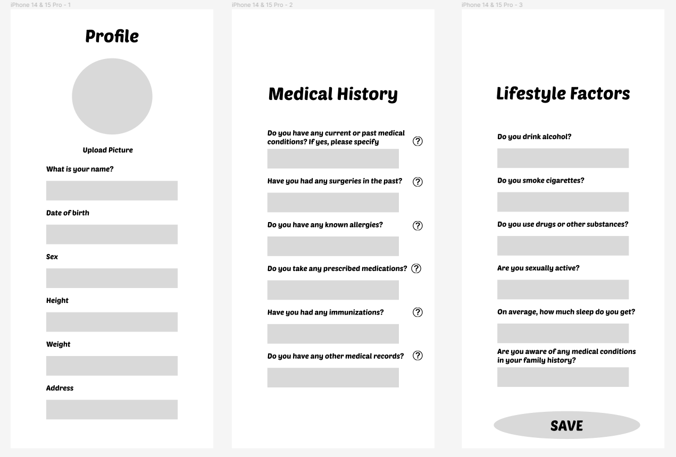

1. **Search Doctors**

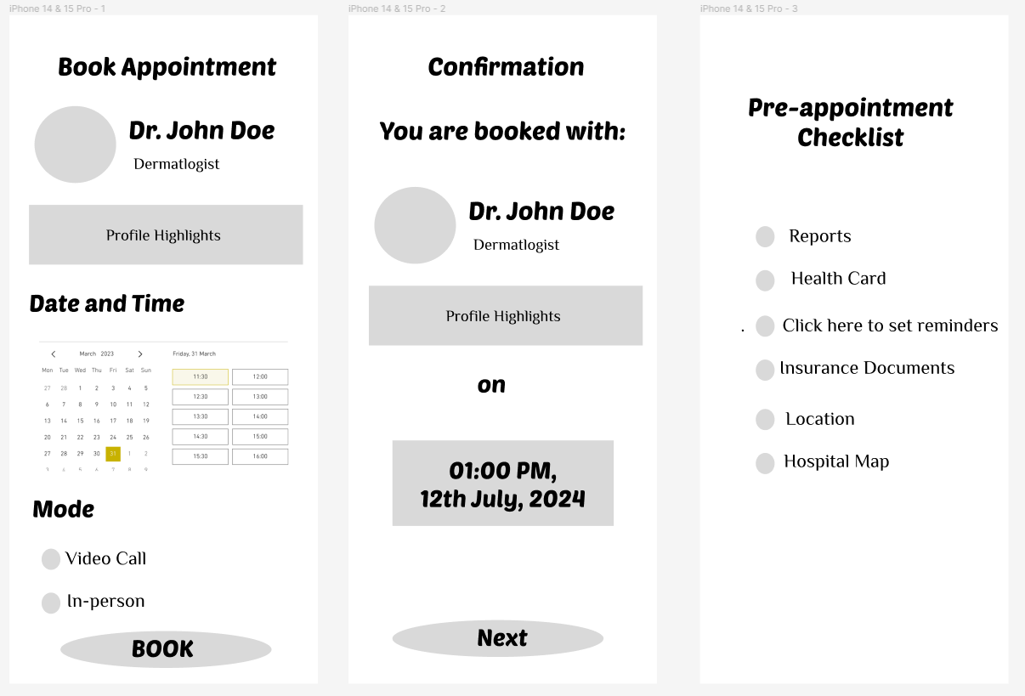

1. **Book Appointment**

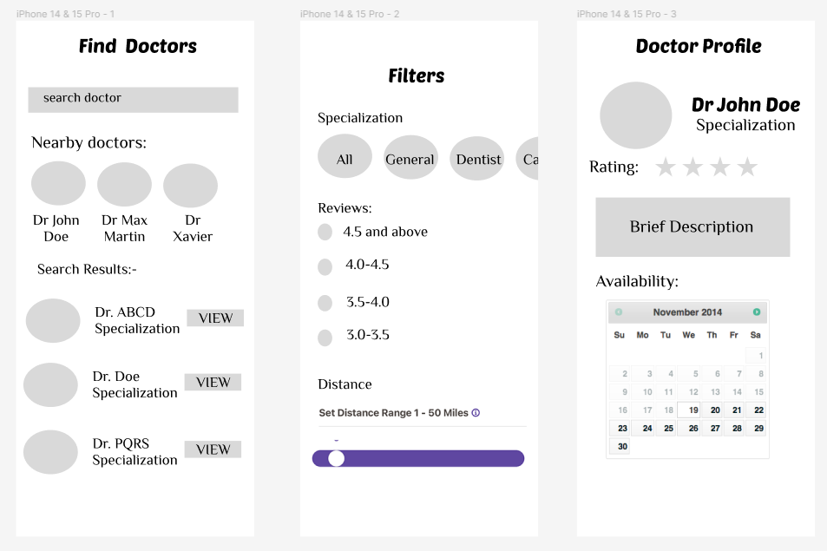

**Prototype II**

Maseerah Khatoon - 002778147

Description: CareConnect is an app to find and book appointments with doctors.

The design prototypes below are of low fidelity nature to be presented to users

for testing multiple tasks including building a profile, searching for doctors using

helpful filters and finally booking appointments.

Tasks:

1. Sign Up and View Services

a. Login by entering username and password or hit sign up

b. Create basic Profile by filling in required fields and hit submit

c. View services offered on home screen

1. Search Doctors and book Appointment

a. Enter search query

b. Set filters

c. Access list of doctors

d. Hit the view button and view doctor’s profiles

e. Select mode, date and time and hit confirm button to book appointment

1. View/Update Patient Profile

a. Medical records: View, share, add and delete using buttons

b. Medical profile: Add type of illness, symptoms, history and medicines through fields provided

c. Access past bookings in the Appointment History section of the profile page

Link to Prototype:

<https://www.figma.com/file/sskEpDZ9IWyIrMWScWsX0h/Low-fidelity-Prototype?type=design&t=j4wMPbiYerjOrAFo-6>

1. **Sign Up and View Services**

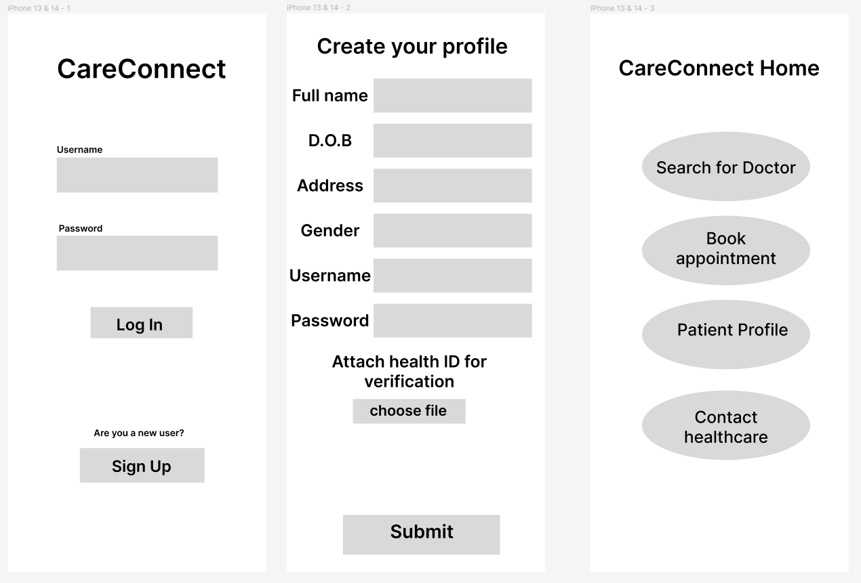

1. **Search for Doctors and book appointment**

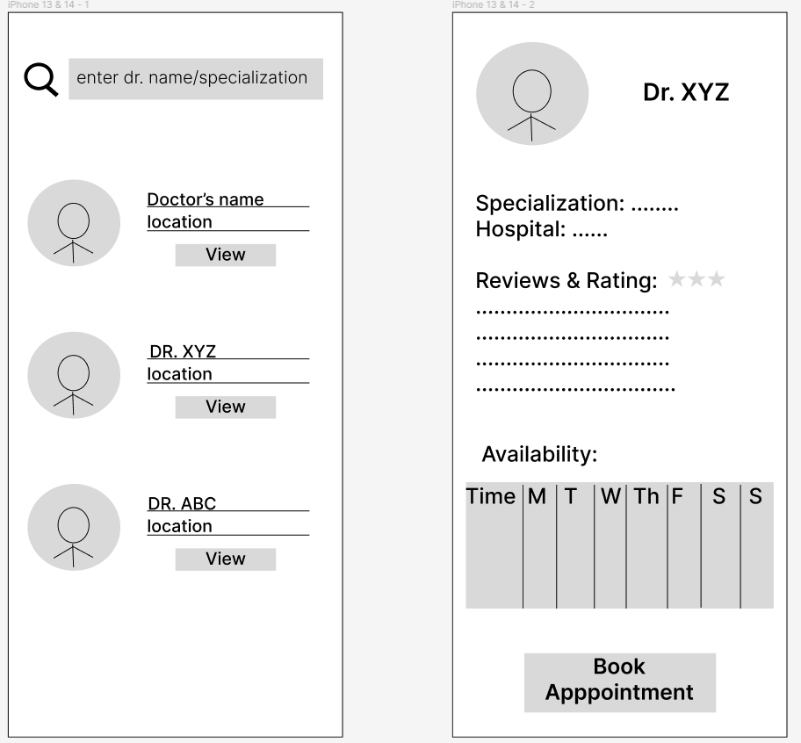 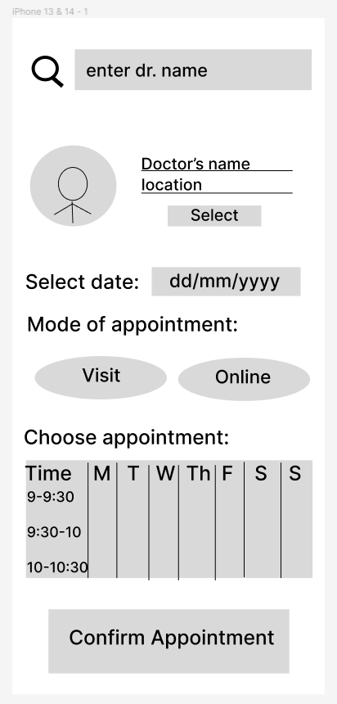

1. **View and Update Profile**

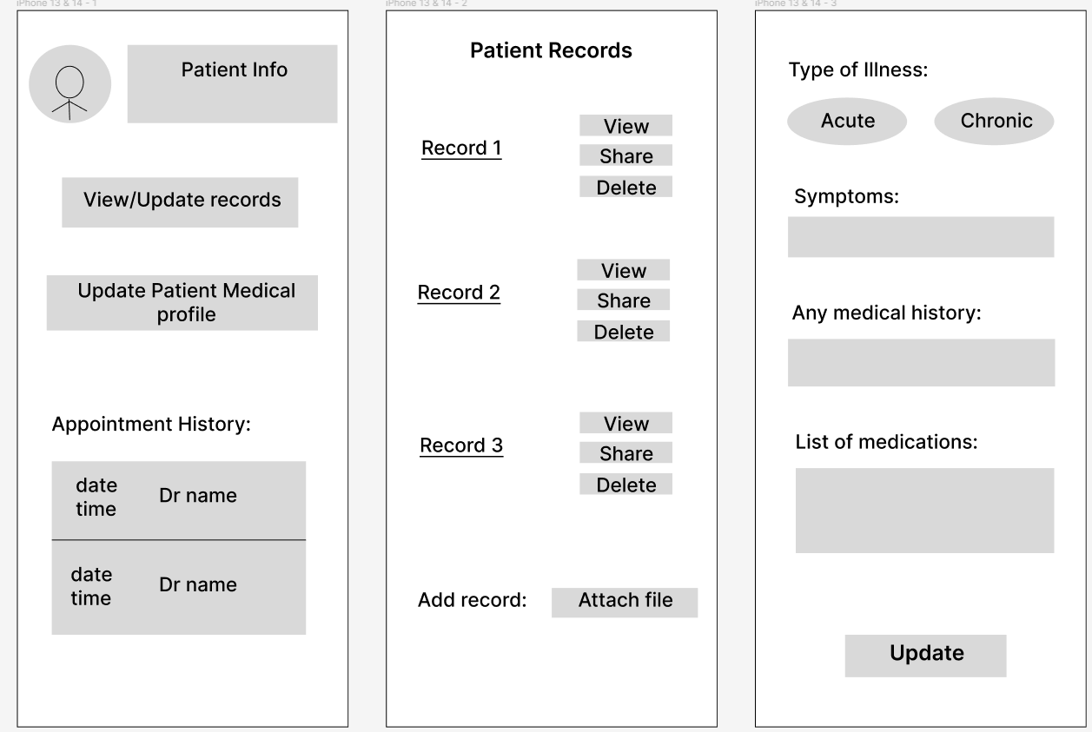

**Prototype: III**

**Made By:** Shaiz Akhtar Mohammad -002796856

**Description**: A digital prototype of Care Connect health application made using Figma based on the tasks and user needs assessed by the survey carried out for user groups including young adults, adults and senior citizens.

**Tasks:**

1. **Build Profile and login**
   1. Read the features of the app on screen and click next
   2. Register in to the app by filing required fields
   3. Login using username and password
2. **Book Appointment** 
   1. In the home screen select Book Appointment
   2. Fill Illness type
   3. Select Hospital
   4. Select Doctor
   5. Choose date and time click on book Appointment
3. **Search Doctor**
   1. In the home screen click on search doctor
   2. Select Province
   3. Select Hospital Name
   4. Select doctor Name
   5. Click on View Profile

**Prototype Link:**

<https://www.figma.com/file/T6oqiIgJm7KRZNe3oFW8YN/Untitled?type=design&node-id=0%3A1&mode=design&t=tvwtEg5aldZedP76-1>

**Start point:**

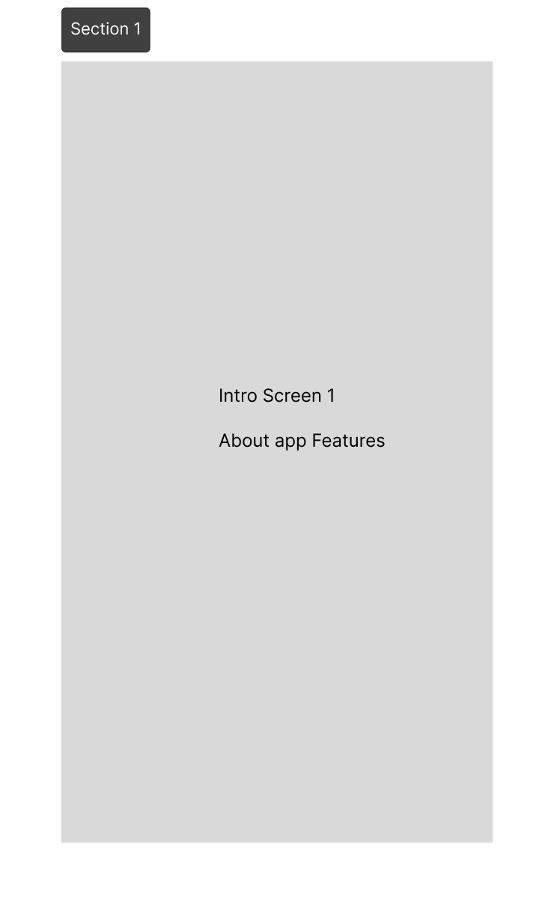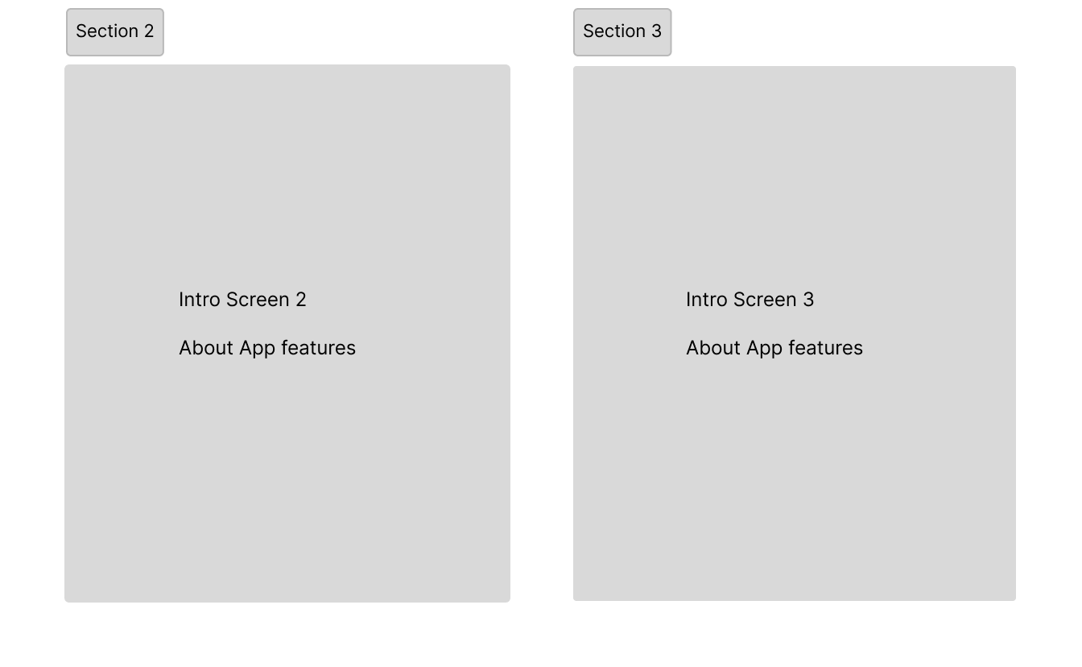

**Build Profile and Login:**

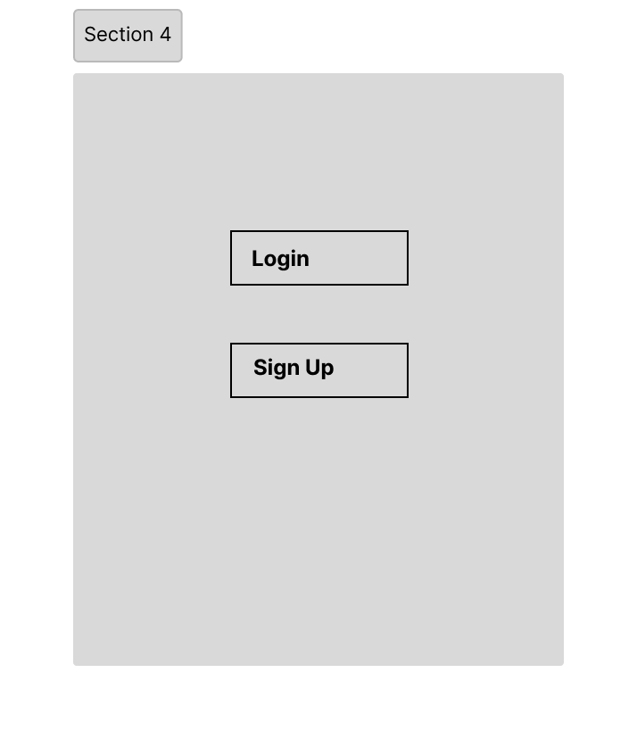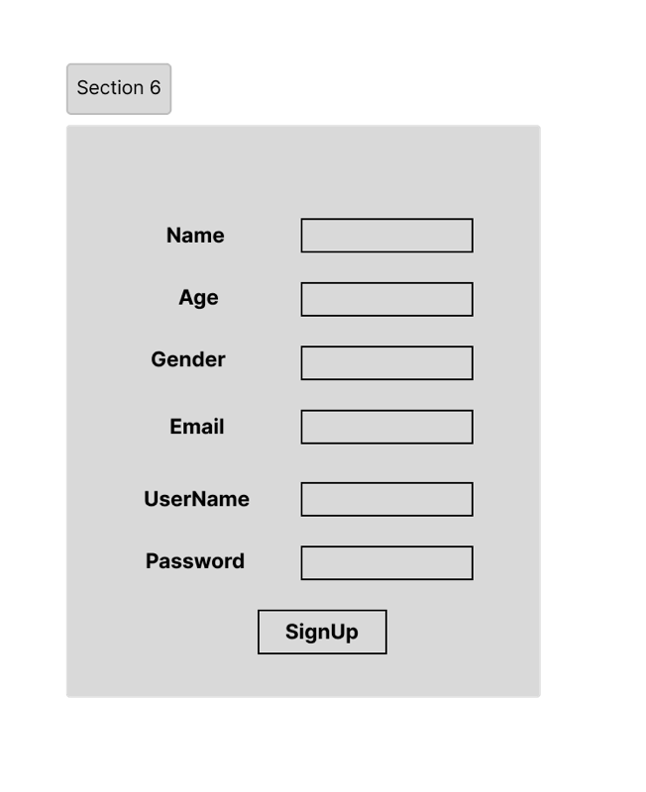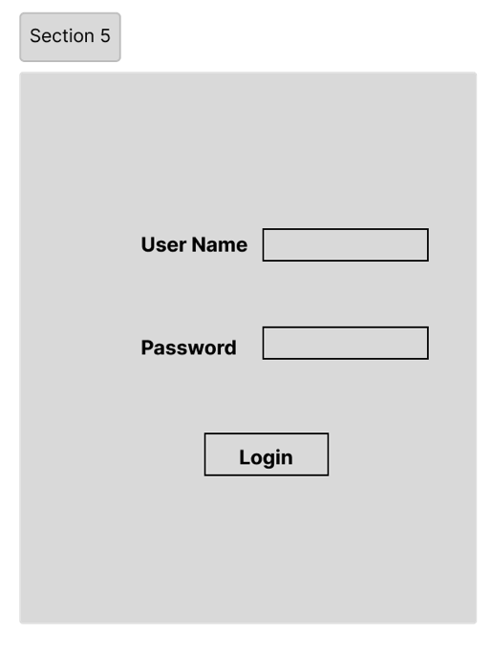

**Book Appointment and My Appointment screen:**

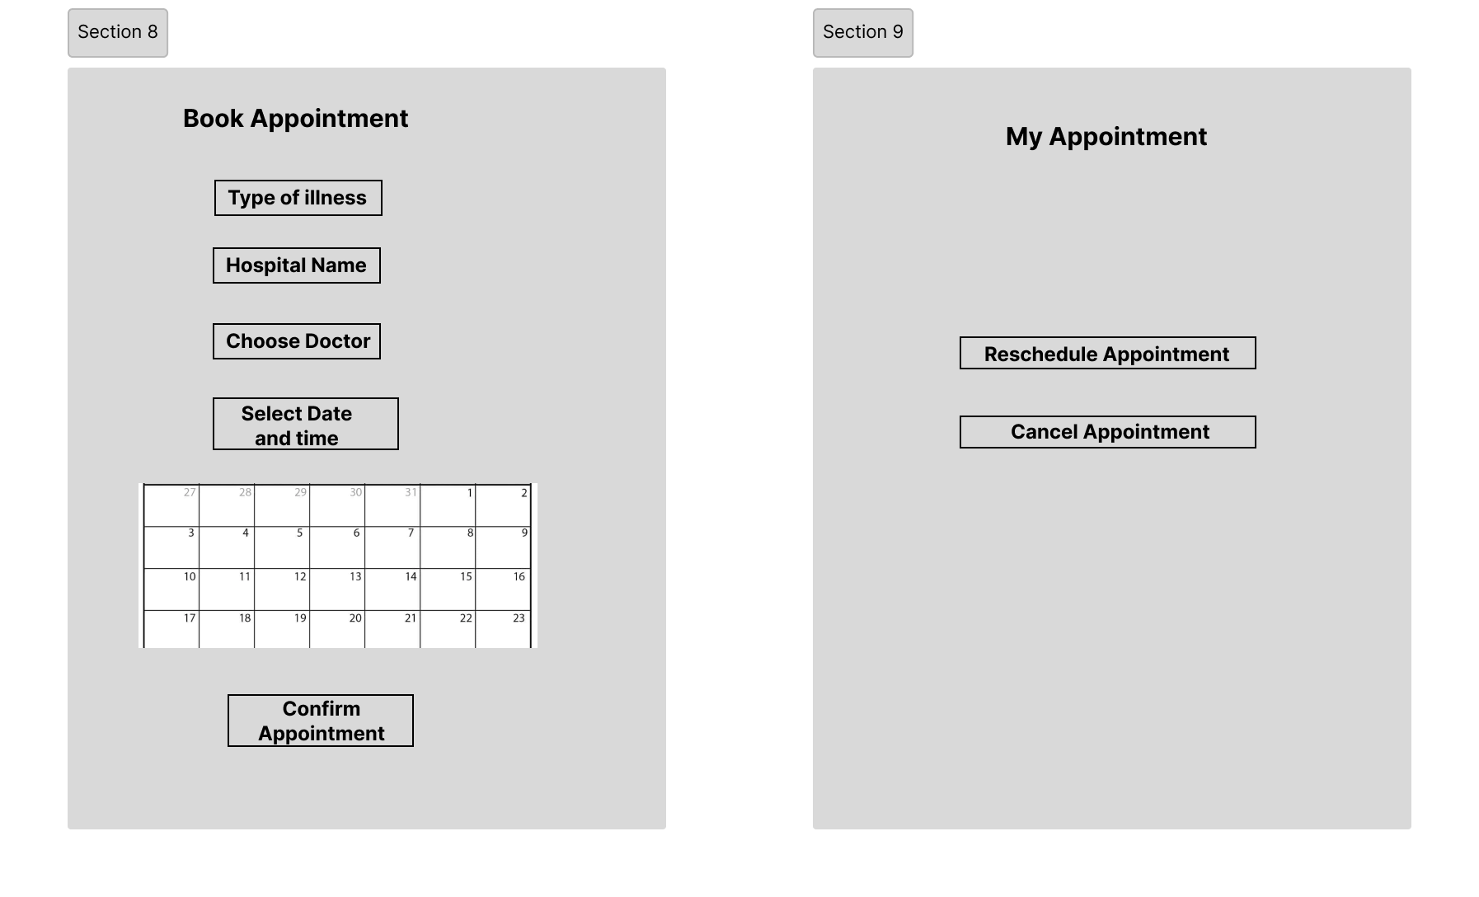

**Search Doctor Screen:**

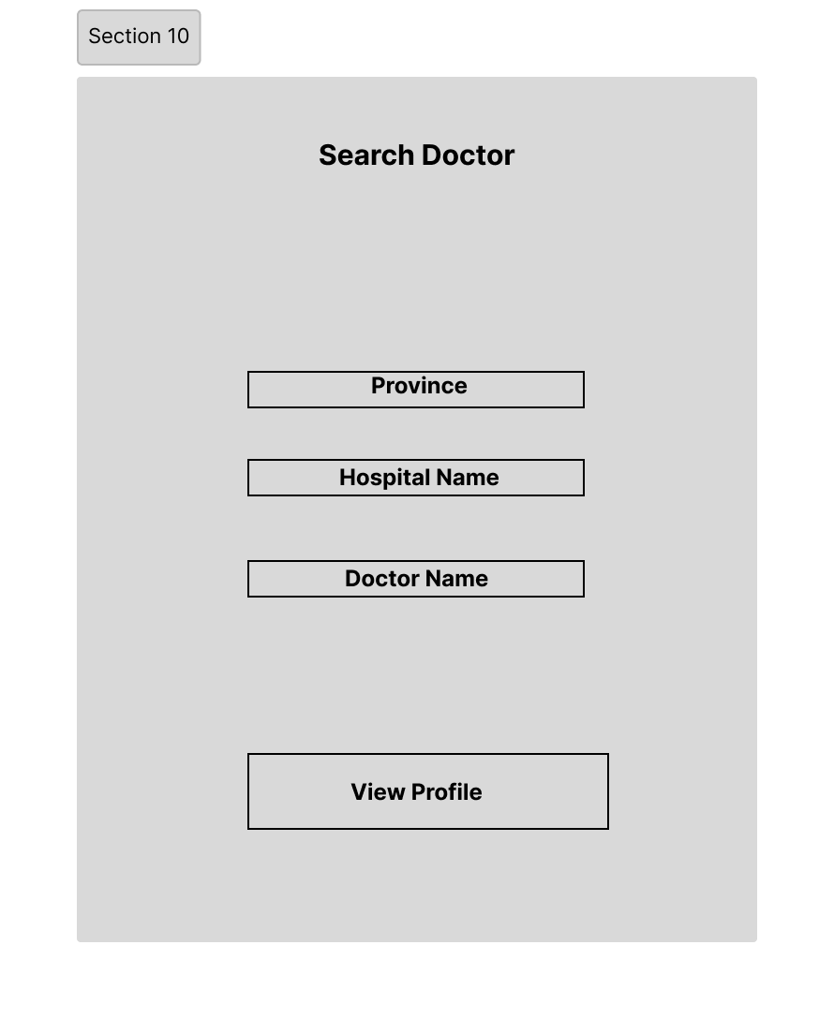

**All Screens in order:**

